**A**

**REPORT ON AI MINI-PROJECT**

**“Expert System on Hospitals And**

**Medical Facilities”**

SUBMITTED TO THE SAVITRIBAI PHULE PUNE UNIVERSITY IN THE PARTIAL FULFILLMENT OF THE REQUIREMENTS FOR THE AWARD OF THE DEGREE

OF

**THIRD YEAR OF ENGINEERING**

**(COMPUTER ENGINEERING)**

SUBMITTED BY

**Patil Sanket Anandrao Exam No.-72029255H**

**Shinde Abhishek Ramesh Exam No.-72029311B**

**Salunke Shubham Nivrutti Exam No.-72029286H**

**DEPARTMENT OF COMPUTER ENGINEERING**

**STES’S SINHGAD ACADEMY OF ENGINEERING**

**KONDHWA, PUNE 411048**

**UNIVERSITY OF PUNE**

**2021-22**



**DEPARTMENT OF COMPUTER ENGINEERING**

**STES’S SINHGAD ACADEMY OF ENGINEERING**

**KONDHWA, PUNE 411048**

**CERTIFICATE**

This is to certify that the AI Mini-project report entitle

**“Expert System on Hospitals And**

**Medical Facilities”**

Submitted by

**Patil Sanket Anandrao Exam No.-72029255H**

**Shinde Abhishek Ramesh Exam No.-72029311B**

**Salunke Shubham Nivrutti Exam No.-72029286H**

is a bonafide work carried out by him/her under the supervision and it is submitted towards the fulfillment of the requirement of Savitribai Phule Pune University, for the award of the degree of Third year of Engineering (Computer Engineering).

**ABSTRACT**

An Expert System is a computer system that emulates the decision making ability of a human expert. Thai is it acts in all respects like a human expert. It uses expert (human) knowledge to solve problems that would require human intelligence. There are a lot of applications in artificial intelligence domain that try to help human experts offering solutions for a problem. This paper describes medical expert systems developed in order to make some predictions regarding various diseases. Expert Systems have applications in different areas of medicine. Here we present a short history of medical expert systems and the characteristics of these systems. Medical expert systems were initially developed for academic areas and later for clinical applications also. Health care systems produce tremendous amounts of information (patient, demographic, clinical and billing data), which are susceptible to analysis by intelligent software and need new techniques to extract new knowledge. A variety of medical expert systems tools are available and can function as intelligent assistants to clinicians, helping in diagnostic processes, laboratory analysis, treatment protocol, and teaching of medical students and residents.

**CONTENTS**

|  |  |
| --- | --- |
| **Sr.No.** | **Name Of Chapters** |
| **1.** | **Abstraction** |
| **2.** | **Introduction** |
| **3.** | **Problem Statement** |
| **4.** | **Objective** |
| **5.** | **Expert System** |
| **6.** | **Early AI/Decision Support Systems** |
| **7.** | **Implementation** |
| **8.** | **Output/Result** |
| **9.** | **Conclusion** |

**I. INTRODUCTION**

An Expert System is a computer system that emulates the decision making ability of a human expert. Thai is it acts in all respects like a human expert. It uses expert (human) knowledge to solve problems that would require human intelligence. There are a lot of applications in artificial intelligence domain that try to help human experts offering solutions for a problem. This paper describes medical expert systems developed in order to make some predictions regarding various diseases.

Expert Systems have applications in different areas of medicine. Here we present a short history of medical expert systems and the characteristics of these systems. Medical expert systems were initially developed for academic areas and later for clinical applications also. Health care systems produce tremendous amounts of information (patient, demographic, clinical and billing data), which are susceptible to analysis by intelligent software and need new techniques to extract new knowledge. A variety of medical expert systems tools are available and can function as intelligent assistants to clinicians, helping in diagnostic processes, laboratory analysis, treatment protocol, and teaching of medical students and residents.

Healthcare services provide information of the diagnosis and continuous monitoring of patient to acquire immediate response and save lives in case of critical conditions. Expert systems in healthcare are important on giving correct information for diagnosis and providing immediate medical services. Current research in decision support system (DSS) uses multiagents for the expert systems.

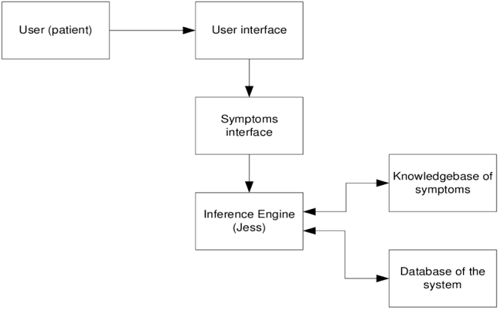

**PROBLEM STATEMENT**

To implement and build the Expert System in the Hospital and Medical Facilities._dataset.csv

**OBJECTIVES**

**-Build the** Expert System in the Hospital and Medical Facilities **and understand it.**

**-Display intelligent behavior.**

-To understand the working of Expert System in AI.

**Expert System:**

An expert system typically consists of four major components:  
**1. Knowledge Base**:

This is the knowledge in the expert system, coded in a form that the system can use. It is developed by some combination of humans (for example, a knowledge engineer) and an automated learning system (for example, one that can learn through the analysis of good examples of an expert’s performance).

**2. Problem Solver**:

This is a combination of algorithms and heuristics designed to use the Knowledge Base in an attempt to solve problems in a particular field.

**3. Communicator**:

This is designed to facilitate appropriate interaction both with the developers of the expert system and the users of the expert system.

**4. Explanation and Help**:

This is designed to provide help to the user and also to provide detailed explanations of the “what and why” of the expert systems activities as it works to solve a problem.

Research into the use of artificial intelligence in medicine started in the early 1970's and produced a number of experimental systems. Till now lots of expert system developed for diagnosis different types of diseases. Expert systems for diagnosis and treatment have been developed for use in a range of medical contexts:

* medical practitioners - hospital doctors, nurses, GP’s, consultants, A & E depts, operating theatre, but also nursing home staff, sometimes parents, patients themselves
* basic tasks - diagnosis, prognosis, treatment, monitoring



**Early AI/Decision Support Systems:**

Some the early Decision Support System in medical diagnosis are discussed here:

1. **AAPHelp:** de Dombal's system for acute abdominal pain (1972).

An early attempt to implement automated reasoning under uncertainty. De Dombal's system, developed at Leeds University, was designed to support the diagnosis of acute abdominal pain and, based on analysis, the need for surgery. The system's decision making was based on the naive Bayesian approach.

1. **INTERNIST I (1974):**

Pople and Myers begin work on INTERNIST, one of the first clinical decision support systems, designed to support diagnosis, in 1970.

INTERNIST-I was a rule-based expert system designed at the University of Pittsburgh in 1974 for the diagnosis of complex diagnosis of complex problems in general internal medicine. It uses patient observations to deduce a list of compatible disease states (based on a tree-structured database that links diseases with symptoms). By the early 1980s, it was recognized that the most valuable product of the system was its medical knowledge base. This was used as a basis for successor systems including CADUCEUS and Quick Medical Reference (QMR), a commercialized diagnostic DSS for internists.

1. **MYCIN:** medical diagnosis using production rules.

MYCIN was the first well known medical expert system developed by Shortliffe at Stanford University to help doctors, not expert in antimicrobial drugs, prescribe such drugs for blood infections (antimicrobial selection for patients with bacteremia or meningitis). MYCIN was a rule-based expert system. It was later extended to handle other infectious diseases. Clinical knowledge in MYCIN is represented as a set of IF-THEN rules with certainty factors attached to diagnoses. It was a goal-directed system, using a basic backward chaining reasoning strategy (resulting in exhaustive depth-first search of the rules base for relevant rules though with additional heuristic support to control the search for a proposed solution). MYCIN was developed in the mid-1970s by Ted Shortliffe and colleagues at Stanford University. It is probably the most famous early expert system, described by Mark Musen as being "the first convincing demonstration of the power of the rule-based approach in the development of robust clinical decision-support systems"

**MYCIN has three sub-systems:**

* **Consultation system** :

Works out possible organisms and suggests treatments.

* **Explanation System** :

MYCIN can answer questions about HOW a conclusion was reached and WHY a question was asked, either after a consultation or while it is going on.

It does this by manipulating its record of the rules it invoked, the goal it was trying to achieve, the information it was trying to discover.

Can also answer general questions (e.g. what would you prescribe for organism X?) by consulting its static data structures.

* **Rule Acquisition system** :

Experts can enter new rules or edit existing rules. The system automatically adds the new rule to the LOOKAHEAD list for all parameters mentioned in its premise, and to the UPDATED-BY list of all parameters mentioned in its action.

**Output/Result:**

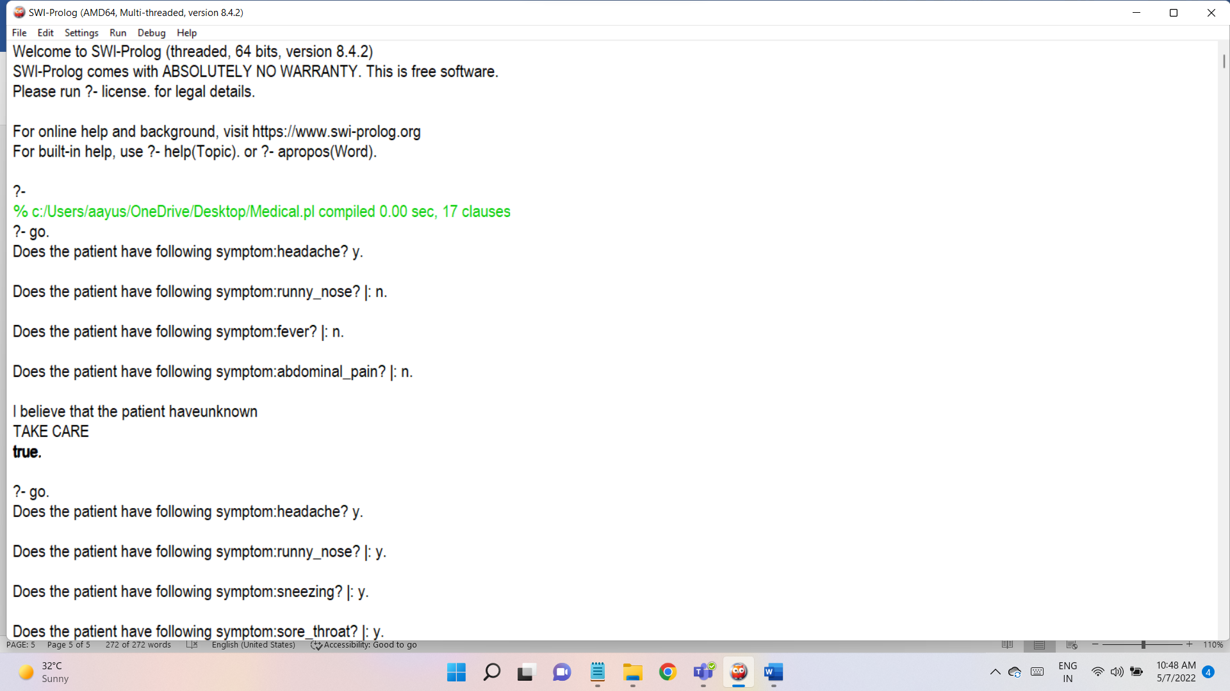

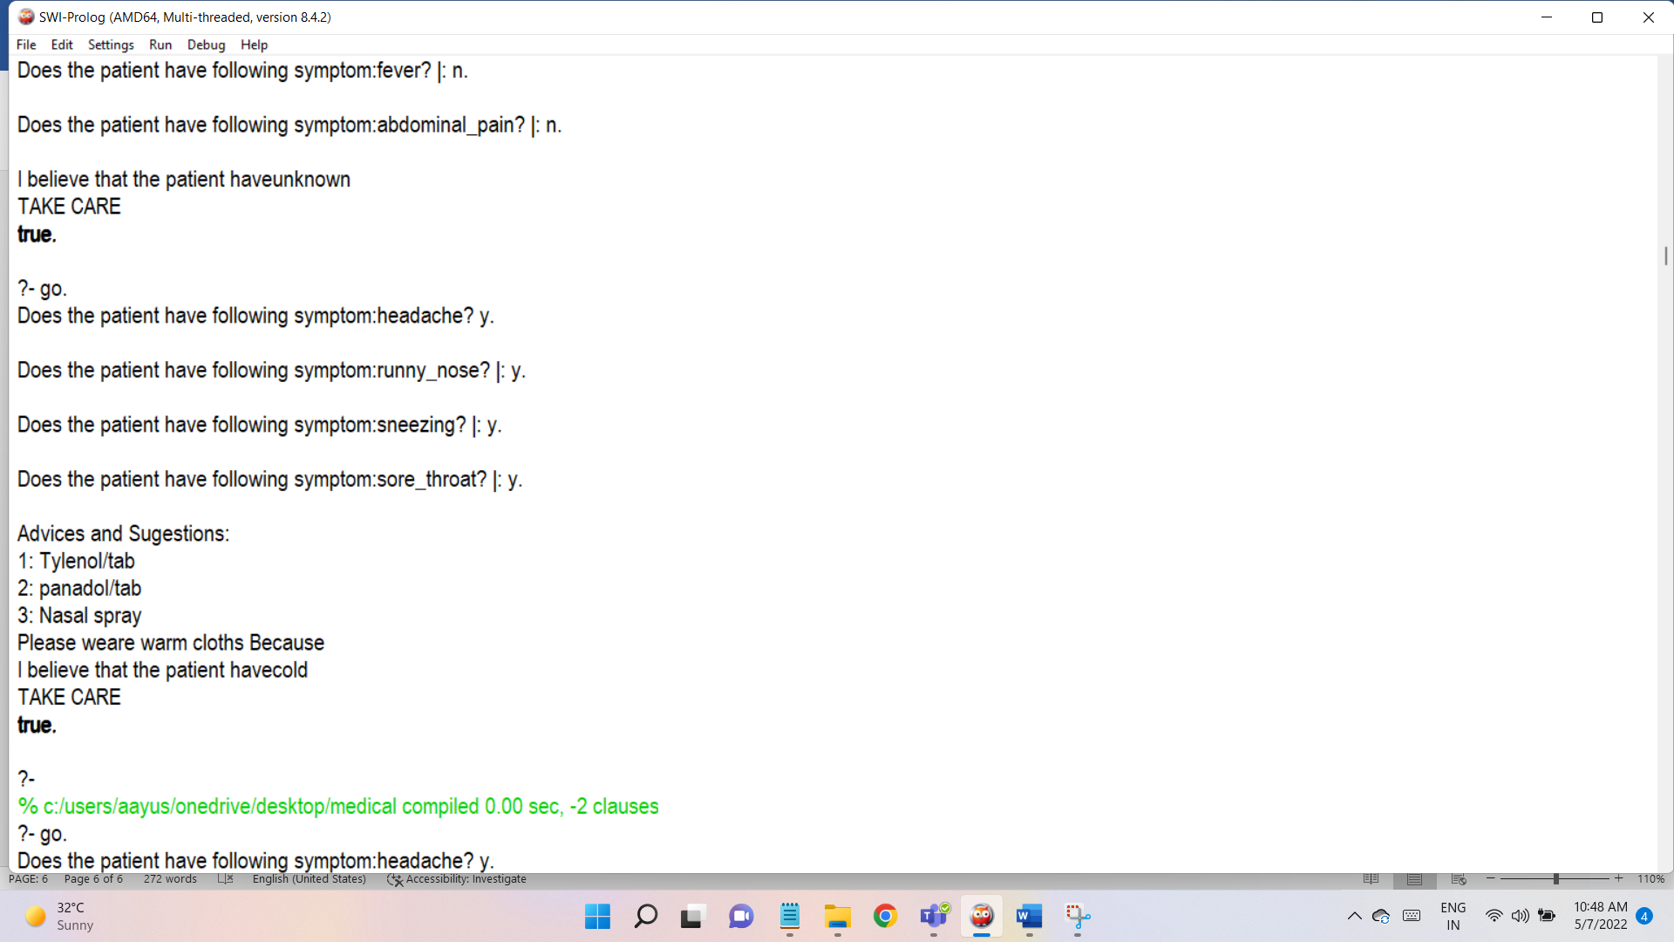

**Conclusion:**

In this project, we conclude that Expert System provides on-line access detailed clinical knowledge that supports decision making tasks from within a traditional software application. We successfully implement Expert System in Hospital and Medical facilities.